LAURIE LUNDQUIST

Willco Art and Design

Tempe, AZ 85281

laurie@laurielundquist.com
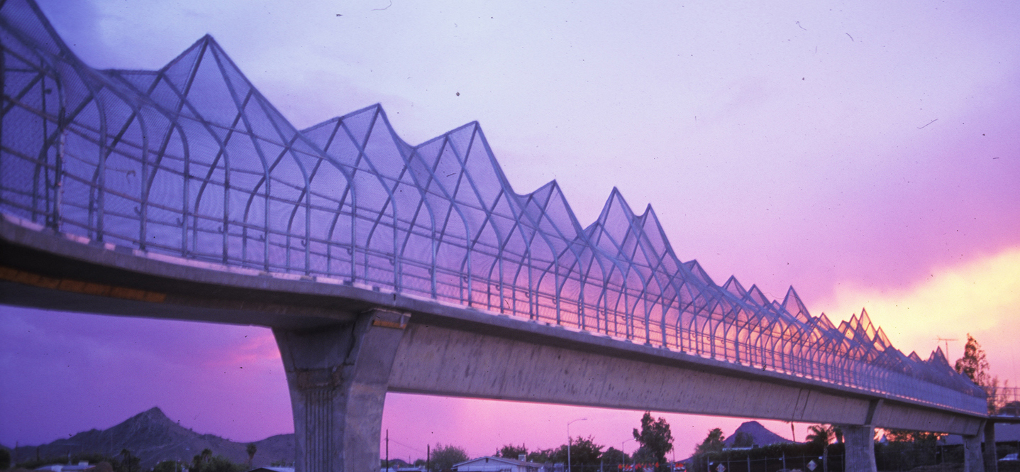

Laurie Lundquist is an environmental artist who brings a deep interest in natural systems and engineering to the design process. Lundquist’s work is original and concept driven she values connection to site in every project.

As a design team artist, Lundquist has collaborated effectively with architects, engineers and planners to integrate art into the overall design of numerous public projects including:

- SkyWaves Pedestrian Overpasses, Fort Lauderdale International Airport construction underway 2015-16 Client: Broward County Aviation Department/ Broward County Cultural Division.
- St Francis Seed Bank, Underpass below St Francis Drive, Santa Fe, New Mexico. Client: City of Santa Fe Arts Commission, under construction 2016.
- Behind Every Wall, Pittsburgh, PA. SR 28 retaining wall sandblasted murals, Michael Baker Jr, Penn DOT 2014
- Galveston Road Overpass, Freeway 101 Chandler, Arizona. Managing Engineer: Dan Heller, T.Y.Lin International 2013
- Tempe Town Lake Pedestrian Bridge, Managing Engineer: Dan Heller T.Y.Lin International, OTAK Architectural. 2011.
- Cross-cut Multi-use Path HDR inc, Studio and Ma 2006- 2009
- Flyover, Pedestrian Overpass, US 60 and Country Club Way, Tempe, Arizona 2004 / Parsons Transportation Group.
- Valley Metro Rail Design Team Artist for Line Section 4 in collaboration with TranSystems inc., Line Section 3 / DWL architects.
- Lay of the Land, Streetscape Phoenix, Arizona 2003 / City of Phoenix Street Transportation Department.
- Sweet Acacia Project (SAP), Scottsdale, Arizona, 2000 / Moore/Swick Partnership.
- Rio Salado Linear Park, South Bank Tempe, Arizona 1998 / Moore/Swick Partnership.
- Mountain Pass Pedestrian Bridge, Phoenix, Arizona, 1998 / HDR & SVR inc.
- Papago Arroyo Wildlife Corridor, Tempe, Arizona , JK Flanagan (1998-1999)
- Rio Salado Bike path, Tempe, Arizona 1995 / Moore/Swick Partnership.

Education:
M F A in Sculpture, Arizona State University, 1990
B F A in Sculpture, Maine College of Art, 1984
Skowhegan School, Visual Arts Residency 1985
Nursery Management (Landscaping) Certificate,
Pennsylvania State University, 1975
Kansas City Art Institute, teaching Fellowship in Sculpture 1990-1991

Awards:
Valley Forward Crescordia Award, Tempe Town Lake Bridge AZ 2012
National Steel Bridge Alliance: Prize Bridge Award, Town Lake 2012
Valley Forward Crescordia Award, Western canal, Tempe AZ 2011
City of Tempe Beautification Award, Flyover Pedestrian Bridge, 2005
Valley Forward Design Excellence Award, Marina water Muse, 2004
Americans for the Arts, Public Arts Network, Year in review, 2004
Papago Salado Design Competition, Metropolitan Phoenix, Arizona, Jurors choice Portals and Loops team. 2002
City of Tempe, Beautification Award, Papago Arroyo, Phase II 2001
City of Tempe Beautification Award, Papago Arroyo, 1999
Valley Forward Design Excellence Award, Mt. Pass Ped.Bridge, 1998
Valley Forward Design Excellence Award, Rio Salado Bike path, 1997

www.laurielundquist.com

